Experiment No. 3
Software Engineering Lab - Use Case Diagram (User's View Analysis)
ContextGuard — Repository-Context-Aware Verification Filtering for Reliable LLM-Based Code Review

Aim
To perform the user's-view analysis for ContextGuard by identifying actors, use cases, and their relationships, and by preparing system-level and role-based use case diagrams.

Learning Outcome
- Perform scenario-based modelling to understand how users and external systems interact with ContextGuard.
- Identify actors and use cases, and the association, <<include>>, <<extend>>, and generalization relationships between them.
- Draw use case diagrams and write formal use case narratives including main, alternative, and exception flows.

Part A – Theory

1. Scenario-Based Modelling
Scenario-based modelling captures how external actors interact with a system to achieve goals. In UML requirements modelling, use cases describe observable system behaviour from the user's point of view rather than implementation details.

2. Developing Use Cases
- Identify the actors that consume information from or provide information to the system.
- For each actor, list the goals they accomplish through the system.
- Represent each goal as a use case with a clear, user-facing name.
- Refine each primary scenario by considering alternate choices, validation failures, external-service failures, and recovery paths.

3. Exceptions
Exceptions describe conditions that cause the normal flow to change, such as an invalid GitHub link, repository access failure, unavailable LLM service, test execution failure, or a reviewer overriding an automated verdict.

4. Relationships Between Use Cases
Relationship | Meaning
Association | A direct interaction between an actor and a use case.
<<include>> | Mandatory behaviour reused by the base use case.
<<extend>> | Optional or conditional behaviour added to a base use case.
Generalization | A specialized actor inherits the interactions of a more general actor.

Procedure
- Analyze ContextGuard's functional requirements from Experiment 1 and the project report.
- List the actors and external systems that interact with the project.
- Group use cases by the actor or dashboard that initiates them.
- Identify mandatory and optional sub-flows using <<include>> and <<extend>>.
- Identify specialized actors using generalization.
- Draw the system-level and role-based diagrams and validate them against the functional requirements.
Output: Use case diagrams and formal use case narratives for ContextGuard.

Part B - Use Case Analysis for ContextGuard
Application: “ContextGuard” is a repository-context-aware verification layer for reliable LLM-based code review. It accepts a GitHub pull request, performs an initial AI review, retrieves relevant repository context through hybrid dense and sparse retrieval, synthesises verification tests, executes original and proposed-fix code, and presents a final evidence-backed verdict. It also provides role-based views for developers, reviewers/maintainers, and engineering managers.

B.1 Actors Identified
Actor | Type | Description
Developer (PR Author) | Primary user | Submits pull requests and receives the verified, evidence-backed verdict.
Reviewer / Maintainer | Primary user | Inspects evidence, reviews flagged PRs, and retains authority to override or approve/reject decisions.
Engineering Manager | Primary user | Monitors false-positive/false-negative rates, ablation results, connected repositories, and evaluation reports.
Repository Administrator | Primary user | Connects repositories and controls the repository scope and retrieval permissions.
QA / Test Auditor | Primary user | Reviews synthesised verification tests and audits verification evidence.
Security / Compliance Reviewer | Primary user | Checks that retrieval is limited to approved repository scope and that sensitive content is protected.
GitHub | External system | Provides pull-request diffs, descriptions, repository metadata, and repository content through its API.
LLM Service | External system | Produces the initial review verdict and assists with query/test synthesis.
Test / Code Execution Environment | External system | Executes the original code and proposed fix against generated verification tests.

B.2 Use Cases Identified (by Owning Actor)
- Developer (PR Author)
Submit / Ingest Pull Request; View Initial AI Verdict; View Verified Final Verdict; View Generated Verification Tests; View Retrieved Evidence; Receive Verdict Notification

- Reviewer / Maintainer
Review Flagged Pull Request; View Evidence-backed Verdict; Inspect Generated Verification Tests; Inspect Retrieved Repository Context; Override ContextGuard Verdict; Approve / Reject Pull Request

- Engineering Manager
View Review Quality Metrics; Compare Baseline vs ContextGuard; View Retrieval Ablation Results; View Connected Repositories; Export Evaluation Report

- Repository Administrator
Connect GitHub Repository; Configure Approved Retrieval Scope; Manage Repository Access

- QA / Test Auditor
Review Synthesised Verification Tests; Audit Verification Evidence; Record Test Audit Outcome

- Security / Compliance Reviewer
Review Retrieval Scope; Audit Repository-Context Access; Verify Compliance Boundary

- GitHub (external)
Provide PR Diff and Metadata; Provide Repository Context

- LLM Service (external)
Generate Initial Review Verdict; Generate Retrieval Query / Hypothetical Test Description; Synthesize Verification Tests

- Test / Code Execution Environment (external)
Execute Original Code; Execute Proposed Fix; Return Test Results

B.3 Use Case Diagrams
The system-level diagram captures the overall interaction between ContextGuard and its human/external actors. Detailed diagrams then focus on the Developer, Reviewer/Maintainer, and Engineering Manager views, matching the project's role-based functional requirements.

Fig. 1 - System-level use case diagram for ContextGuard
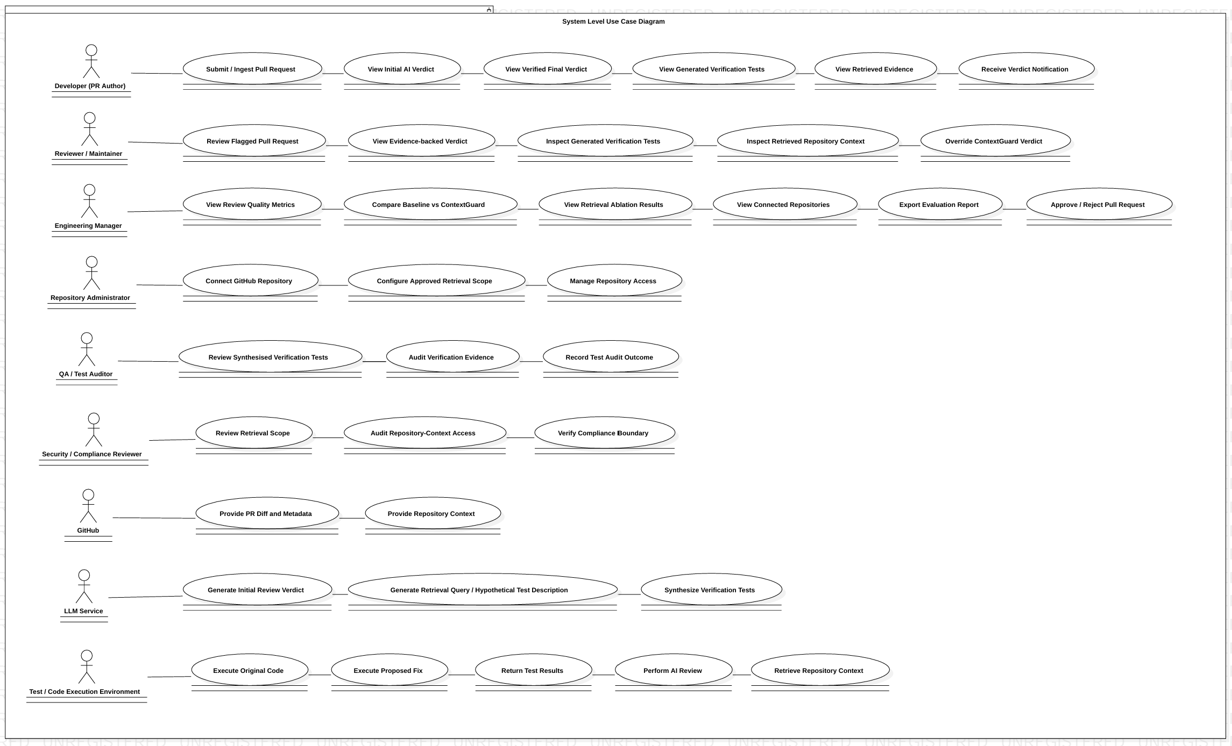
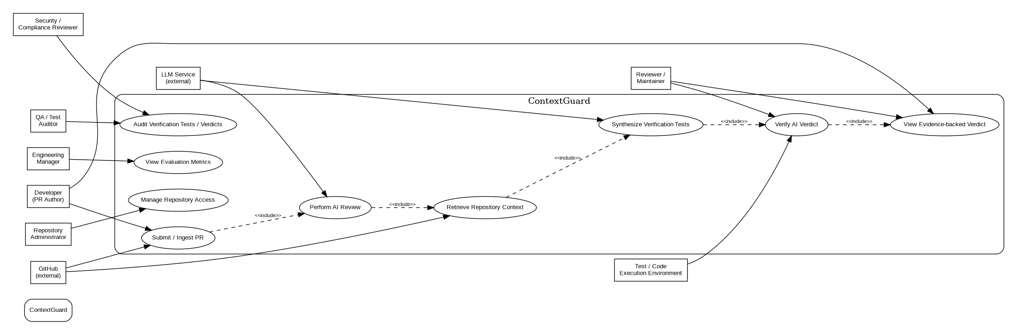
Fig. 2 - Use case diagram: Developer View
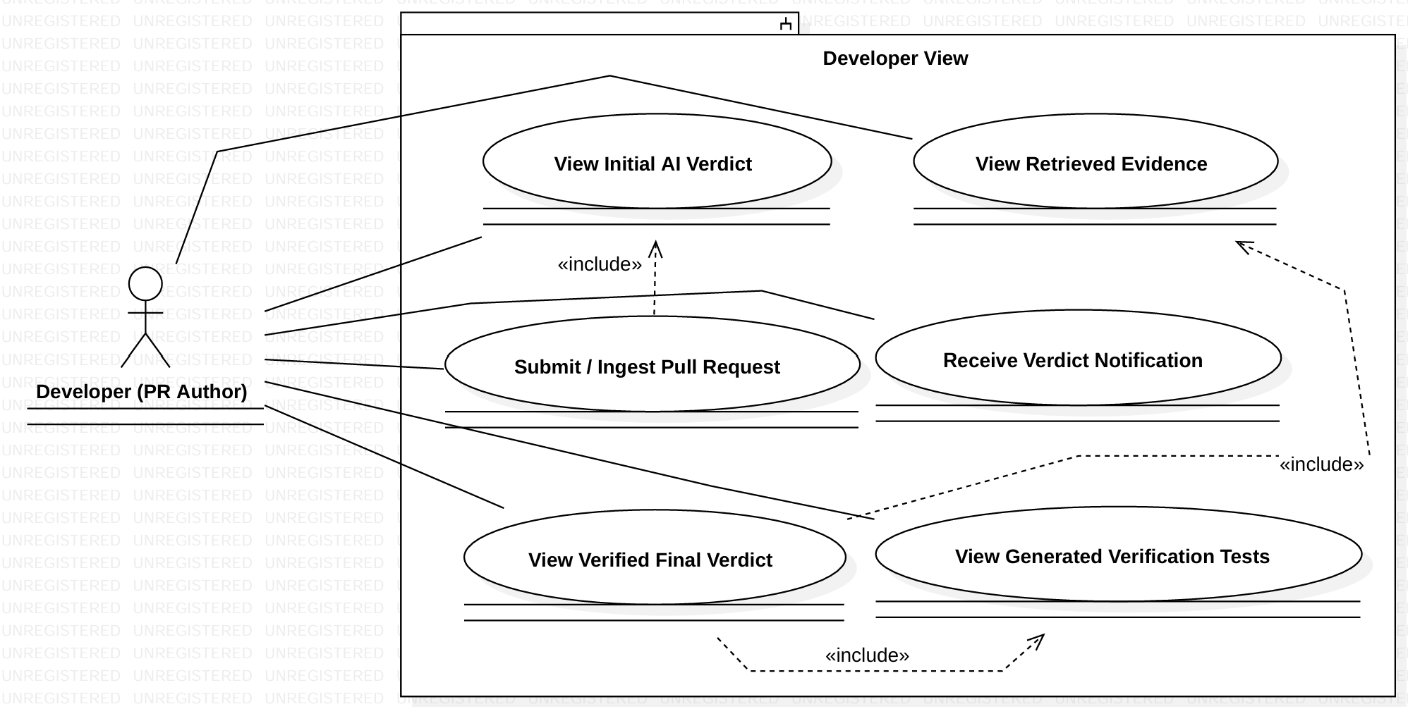
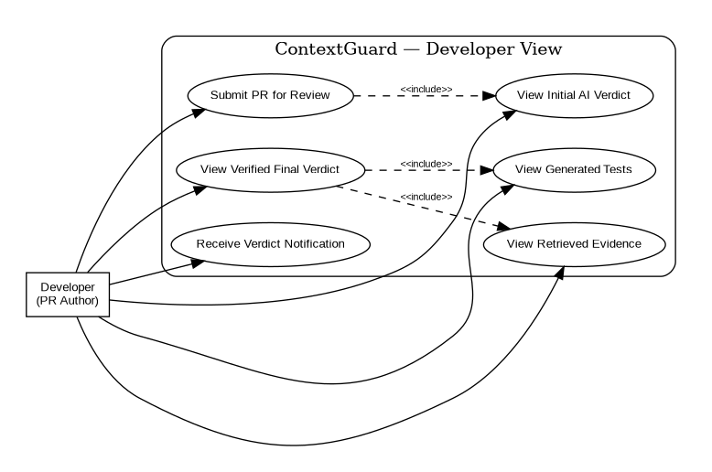
Fig. 3 - Use case diagram: Reviewer / Maintainer View
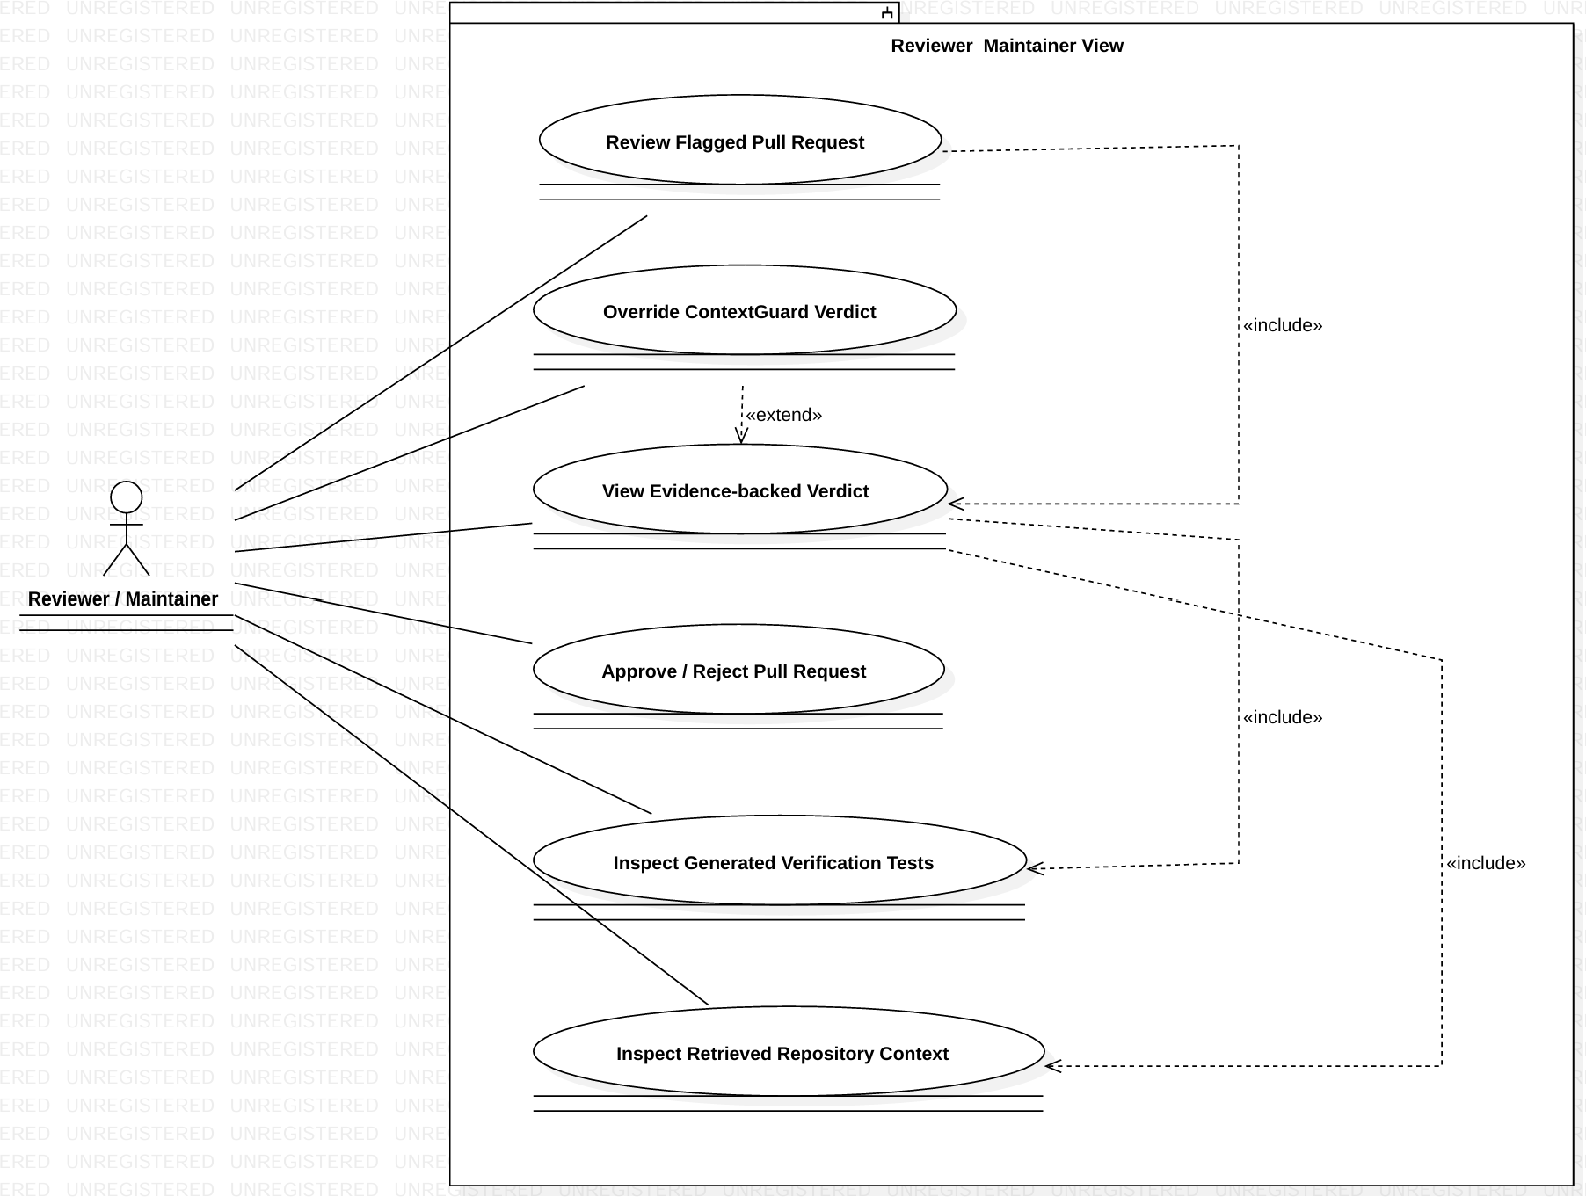
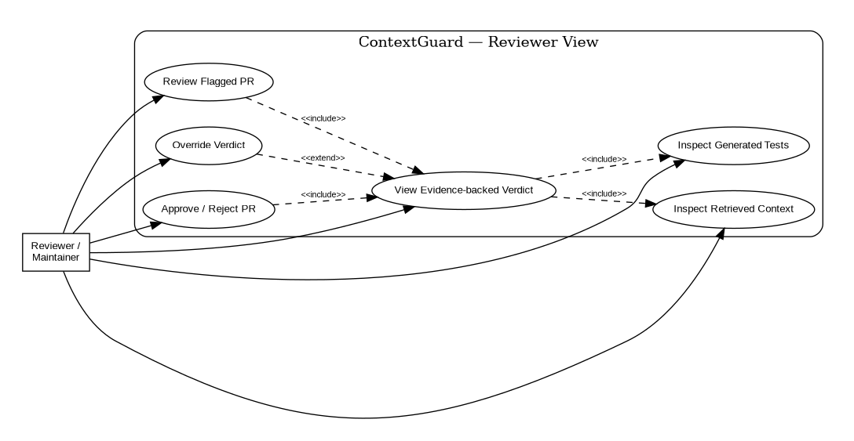
Fig. 4 - Use case diagram: Engineering Manager / Evaluation View
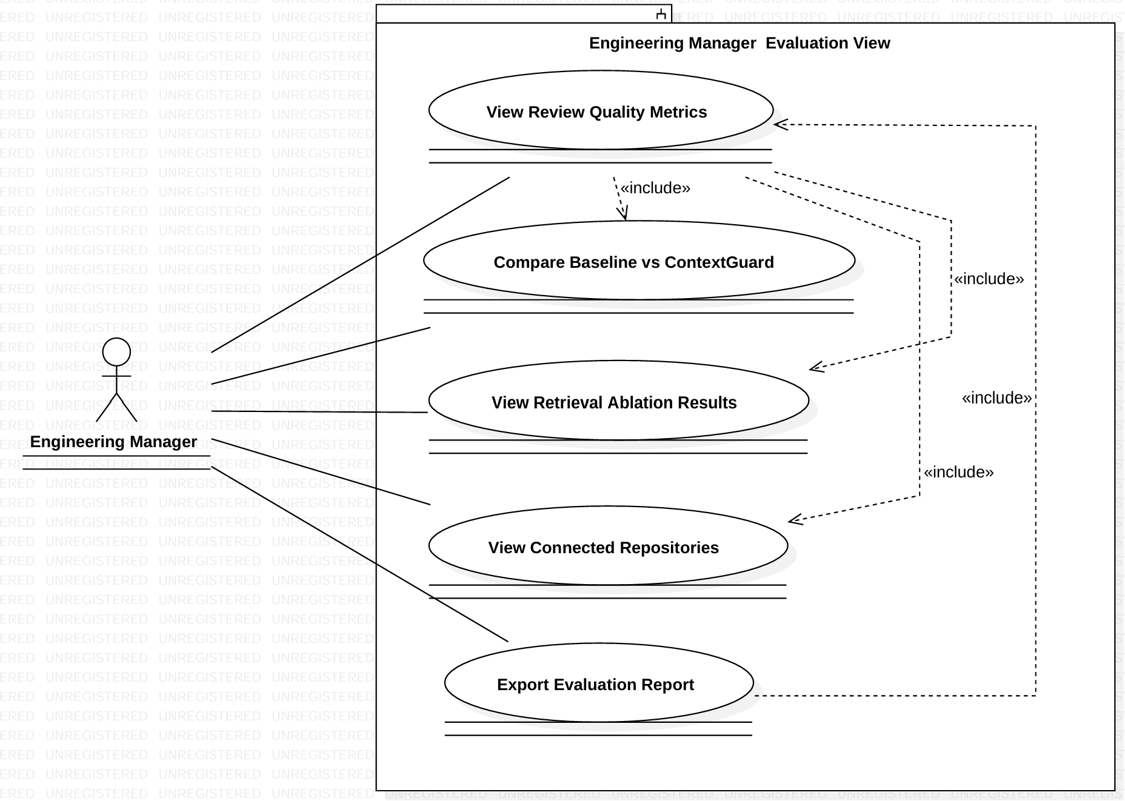
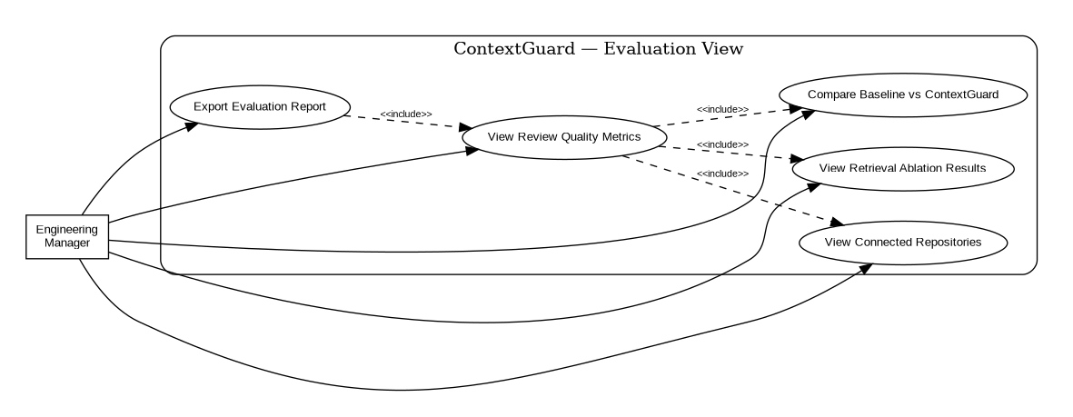

B.4 Relationships Used Across the Diagrams
Relationship | Where used in ContextGuard
Association | Developer–Submit PR; Reviewer–View Verdict; Manager–View Metrics; Administrator–Connect Repository; GitHub–Provide PR Diff; LLM–Generate Review; Test Environment–Execute Code.
<<include>> | Submit / Ingest PR includes Perform AI Review; flagged review includes Retrieve Repository Context; retrieval includes Synthesize Verification Tests; verification includes Execute Original Code and Execute Proposed Fix; final verdict includes View Evidence.
<<extend>> | Override ContextGuard Verdict extends View Evidence-backed Verdict; error/recovery paths such as failed repository access or failed test execution are treated as alternate/exception behaviour rather than mandatory sub-flows.
Generalization | Developer, Reviewer/Maintainer, Engineering Manager, Repository Administrator, QA/Test Auditor, and Security/Compliance Reviewer are distinct role actors. If a common 'ContextGuard User' actor is desired in StarUML, these roles can be generalized from it.

B.5 Detailed Use Case Descriptions

UC-01 - Submit / Ingest Pull Request
Primary Actor | Developer (PR Author)
Secondary Actor(s) | GitHub
Precondition | Developer has a valid GitHub pull-request link and the repository is connected to ContextGuard.
Main Flow | 1. Developer submits the PR link.  2. System validates the link and repository connection.  3. System requests the PR diff, linked issue/description, and repository metadata from GitHub.  4. System stores the intake information and starts the AI review workflow.
Include / Extend | <<include>> Perform AI Review
Exception Flow | E1: Invalid or inaccessible PR → system displays an error and does not start verification. E2: GitHub API unavailable → system retries or marks the run as pending and notifies the user.
Postcondition | The PR is accepted for review and an initial AI review run is created.

UC-02 - Verify AI Verdict
Primary Actor | Reviewer / Maintainer
Secondary Actor(s) | LLM Service; Test / Code Execution Environment
Precondition | An AI review has flagged a PR as non-compliant and a proposed fix is available.
Main Flow | 1. System retrieves relevant repository functions, tests, and discussion.  2. System synthesises verification tests grounded in retrieved context.  3. System executes the original code against the tests.  4. System executes the proposed fix against the same tests.  5. System compares the outcomes and determines whether the original flag is confirmed or corrected.  6. System records the final verdict with evidence and exposes it to the developer/reviewer.
Include / Extend | <<include>> Retrieve Repository Context; <<include>> Synthesize Verification Tests; <<include>> Execute Original Code; <<include>> Execute Proposed Fix
Exception Flow | E1: No sufficiently relevant context → system marks evidence as insufficient and requests reviewer attention. E2: Test execution fails unexpectedly → verification run is marked inconclusive rather than silently confirming the verdict. E3: Both versions behave identically → the non-compliance flag is corrected as a likely false positive.
Postcondition | A confirmed or corrected evidence-backed verdict is recorded.

UC-03 - View Evidence-backed Verdict
Primary Actor | Developer (PR Author) / Reviewer
Secondary Actor(s) | System
Precondition | A final or unverified verdict has been recorded for the PR.
Main Flow | 1. Actor opens the PR result.  2. System displays the original verdict and final verdict.  3. System displays generated tests and retrieved evidence.  4. System identifies whether the verdict was confirmed, corrected, or left unverified.  5. Actor uses the evidence to decide the next action.
Include / Extend | <<include>> View Generated Verification Tests; <<include>> View Retrieved Evidence
Exception Flow | E1: Evidence is incomplete → system clearly marks the result as incomplete/unverified instead of hiding missing evidence.
Postcondition | The actor can understand the reason and evidence behind the automated decision.

UC-04 - Connect GitHub Repository
Primary Actor | Repository Administrator
Secondary Actor(s) | GitHub
Precondition | Administrator is authenticated and has permission to authorize the repository.
Main Flow | 1. Administrator selects Connect Repository.  2. System requests GitHub authorization.  3. GitHub grants read access.  4. System records the connected repository and approved scope.  5. Administrator confirms or adjusts retrieval permissions.
Include / Extend | <<include>> Configure Approved Retrieval Scope
Exception Flow | E1: Authorization denied → repository remains disconnected. E2: Repository is outside the approved organisation/scope → system rejects the connection.
Postcondition | The repository is connected with a recorded access scope.

B.6 Traceability to Experiments 1 and 2
The use cases are directly traceable to the earlier requirement work. Experiment 1 defines the functional flows: PR ingestion, automated LLM review, repository-context retrieval, test synthesis, fix-guided verification, explainable output, repository connection, and evaluation dashboard. Experiment 2 adds quality constraints such as verification turnaround, retrieval security, availability, auditability, access control, and recoverability. The use-case model therefore focuses on externally observable goals while keeping those NFRs as constraints/acceptance criteria.

B.7 Versioning the Requirement Document
This document represents Version 1.0 of the ContextGuard use-case model. As the prototype evolves, new actors, use cases, alternative flows, and relationships may be added in later versions (V1.1, V1.2, …). Superseded versions should be retained for traceability.

Conclusion
Performing the user's-view analysis surfaced the human roles and external systems that interact with ContextGuard and converted the functional requirements into a structured set of use cases. The model highlights the core verification flow—PR intake, AI review, repository-context retrieval, test synthesis, execution, and evidence-backed final verdict—while preserving role-specific views for developers, reviewers/maintainers, and engineering managers.

